**Power BI Repository**

**Introduction**

Power BI is a powerful business intelligence tool from Microsoft that allows users to transform raw data into meaningful insights through interactive dashboards and reports. This guide walks you through the process of getting started with Power BI, from installation to creating your first dashboard, with detailed explanations of its tools and features.

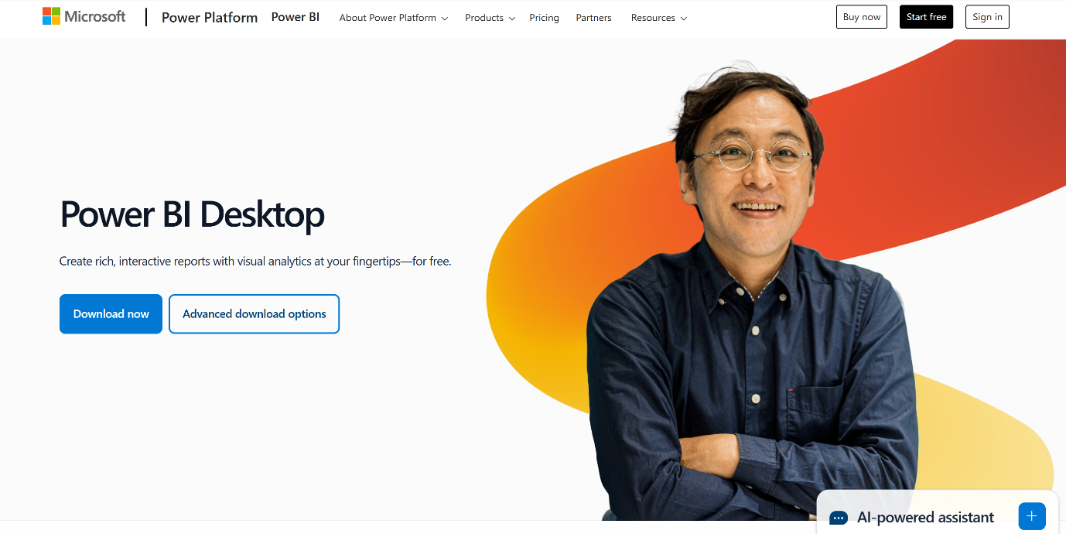

**Step 1: Installation**

**1.1 System Requirements**

Before installing Power BI, ensure your system meets the following requirements:

* **Operating System**: Windows 10 (64-bit) or later.
* **RAM**: Minimum 4 GB (8 GB or more recommended).
* **Processor**: 1 GHz or faster (x64-bit processor recommended).
* **Disk Space**: At least 1 GB of available disk space.

**1.2 Download Power BI Desktop**

1. Visit the [official Power BI website](https://powerbi.microsoft.com/).
2. Navigate to the "Products" section and select **Power BI Desktop**.
3. Click on the **Download free** button.
4. You will be redirected to the Microsoft Store page. Click **Get** to download and install the application.

Alternatively, you can download the installation file directly from the Power BI website as an .exe file.

**1.3 Installation Process**

1. Open the downloaded .exe file.
2. Follow the on-screen instructions to install Power BI Desktop.
3. Launch Power BI Desktop after installation is complete.

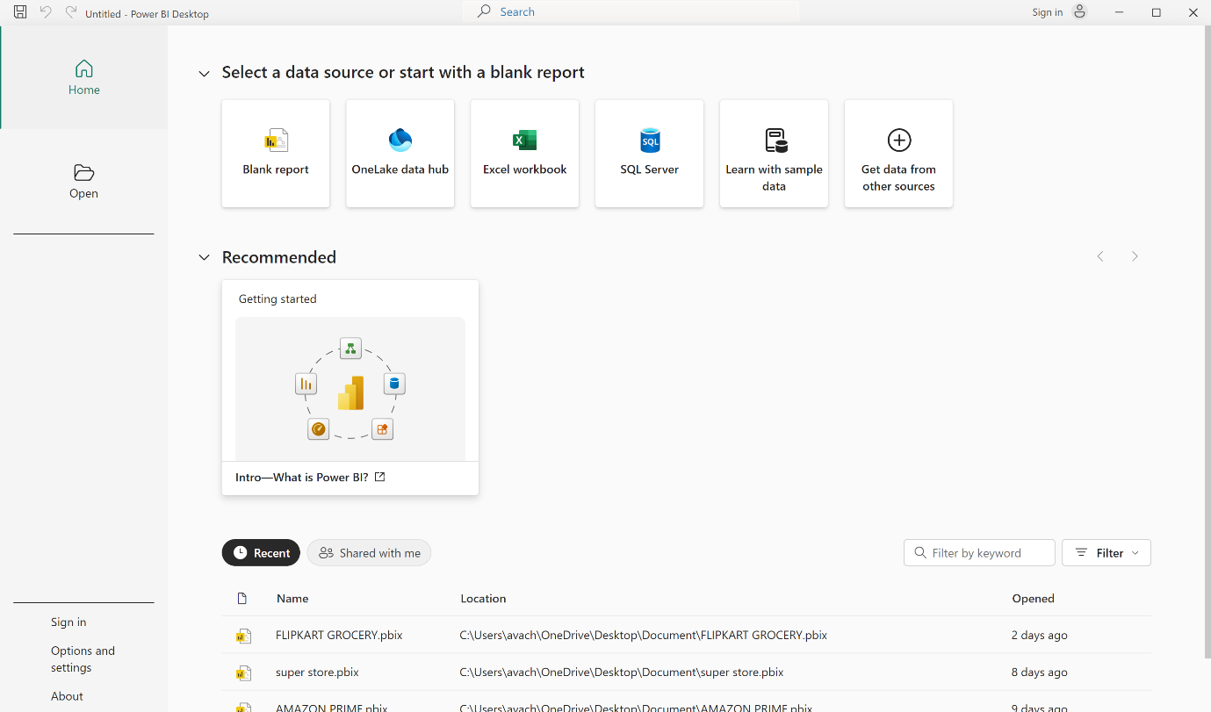

**Step 2: Understanding the Power BI Interface**

The Power BI Desktop interface consists of the following main components:

**2.1 Home Tab**

* **Get Data**: Import data from various sources such as Excel, SQL Server, online services, and more.
* **Recent Sources**: Access recently used data sources.
* **Enter Data**: Manually enter data into Power BI.

**2.2 Report View**

The central workspace where you design and customize your reports and dashboards using visualizations, filters, and formatting options.

**2.3 Data View**

Provides a tabular view of your imported data. You can view and edit data, create new calculated columns, and format data types.

**2.4 Model View**

Enables you to create and manage relationships between tables, which is crucial for data modeling and creating meaningful insights.

**2.5 Visualizations Pane**

Contains a variety of visualization types, such as:

* Bar charts
* Line charts
* Pie charts
* Maps
* Tables
* Matrix visuals

You can also customize and format visualizations from this pane.

**2.6 Fields Pane**

Displays all the tables and columns imported into your project. You can drag and drop fields onto the report canvas to create visualizations.

**2.7 Filters Pane**

Used to apply filters to visualizations, pages, or the entire report.

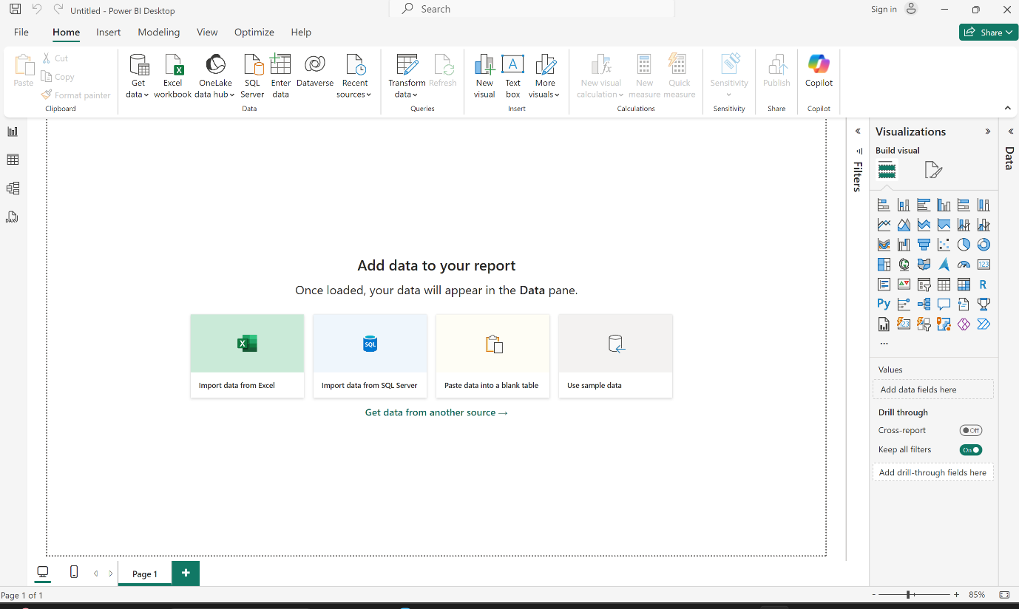

**Step 3: Importing Data**

1. Click **Get Data** from the Home tab.
2. Select the data source you want to use (e.g., Excel, SQL Server, Web).
3. Click **Connect** and follow the prompts to load the data into Power BI.
4. Preview your data and click **Load** or **Transform Data** to proceed.

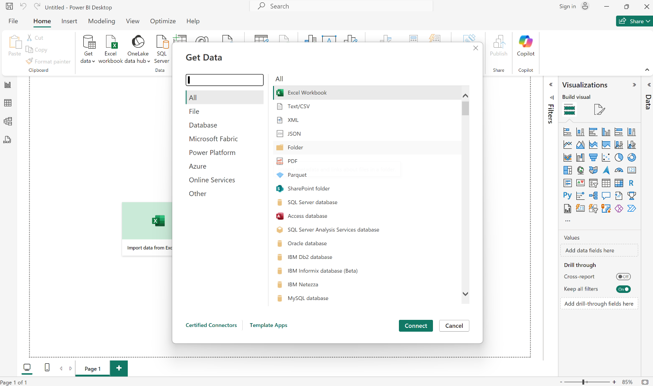

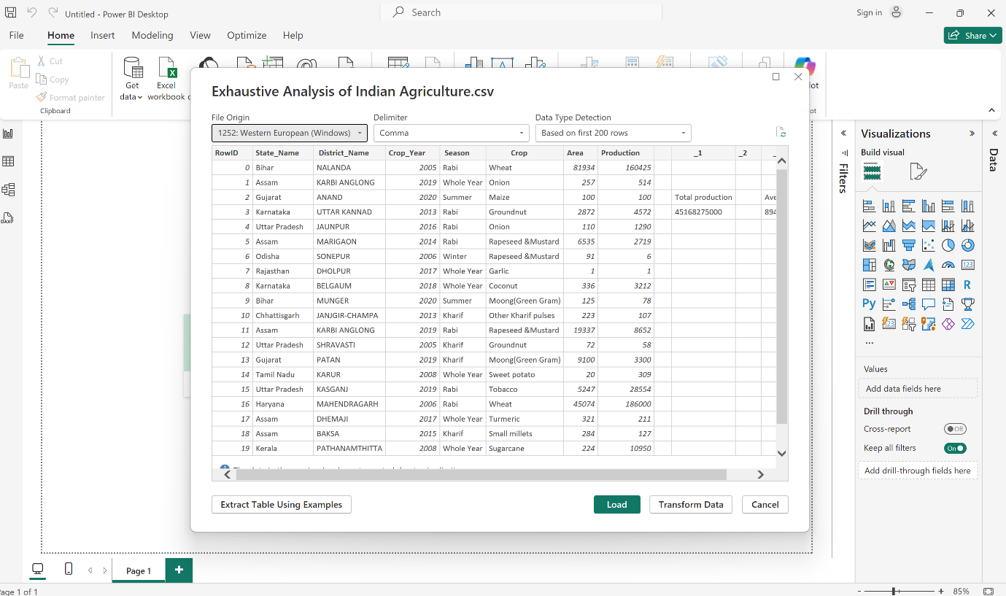

**Step 4: Data Transformation**

Power Query Editor allows you to clean and transform your data:

* **Remove Duplicates**: Eliminate duplicate rows.
* **Split Columns**: Split data in a single column into multiple columns.
* **Merge Queries**: Combine data from multiple tables.
* **Add Columns**: Create new calculated columns.
* **Replace Values**: Find and replace specific values in your data.
* **Add Columns**: Create new calculated columns.
* **Replace Values**: Find and replace specific values in your data.
* **Remove Columns**: You can remove unnecessary columns to clean up your data. If you need to restore a removed column, use the "Applied Steps" pane on the right-hand side to undo the column removal or re-import the data.

The Power Query Editor ensures that all transformations are recorded as steps. This makes it easy to modify or revert any changes without starting over.

Once transformations are complete, click **Close & Apply** to load the transformed data.

